Attached is our example layout for a missing pets poster, its simple to change and put in your pets details, simply click on the text and add the details :
NAME
SEX
AGE
BREED
COLOUR
CHIPPED YES/NO

Right click on the picture and select ‘CHANGE PICTURE’’ and select a picture of your own pet on your phone and PC to replace it.

And remember to include anything important at the bottom such as if they say have a limp, chunk missing out of their left ear, anything that will help people identify it as your pet and not another one, also include details of where and when it was last seen and if there is a reward being offered.

Put your name and a contact number at the bottom, make this this number is either a mobile where you can see if you have missed a call or a number that is always answered or has an answer machine so you don’t miss any calls.

If you are putting up posters outside either laminate them or get some plastic sleeves and remember to put the opening at the bottom so water does not get inside, also when laminating have the opening at the bottom as again it will help prevent any water getting in.

We are able to help with posters, contact us using the details on our website and we will help where we can.

There is also a page on our website with details of what to do if you pet goes missing, who to contact and where to put posters.

www.arsenalpetsitting.co.uk

We hope you are soon reunited with your little one

Arsenal Pet Sitting


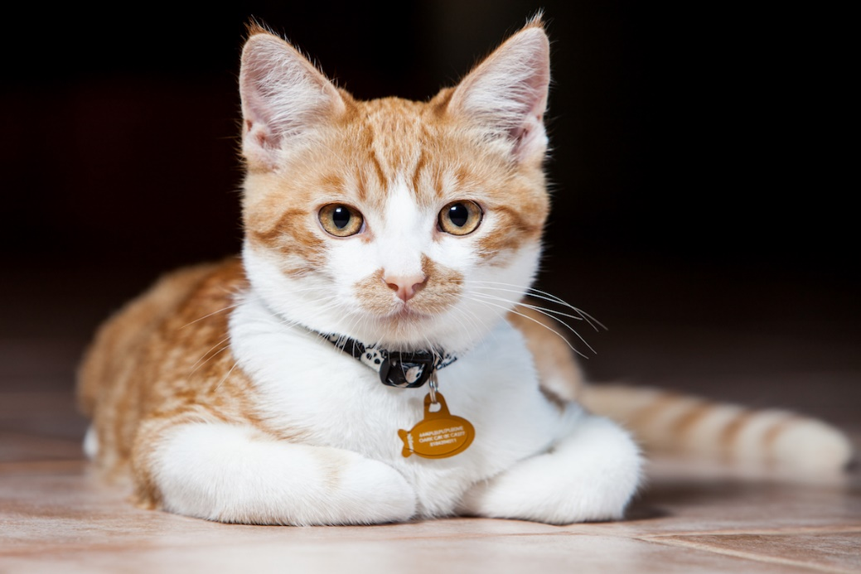
NAME :
SEX :
AGE :
BREED :
COLOUR :
CHIPPED :

MISSING CAT!
WWW.ARSENALPETSITTING.CO.UK
IF YOU HAVE ANY INFORMATION PLEASE CONTACT
NAME
Phone Number
ARSENAL PET SITTING
HELPING REUNITE OWNERS WITH THEIR PRECIOUS PETS
PUT IN OTHER IMPORTANT INFORMATION HERE THIS INCLUDES WHERE AND WHEN THEY WERE LAST SEEN, ANYTHING UNIQUE ABOUT THEM AND IS THEIR A REWARD BEING OFFERED.

